**CAPSTONE PROJECT**

**Objective: -** The pharmaceutical companies use a cooling chamber which is similar to a refrigerator to keep the tablets and maintain the temperature in the required limits. However, since you most probably don’t have a cooling chamber which can maintain a temperature in the range, of -40 to -30 degrees Celsius, you can instead use a regular refrigerator at your home for this project.

**Apparatus Used: -**

**1.** Bolt IoT Device

**2.** Temperature Sensor (LM35)

**3.** Jumper Wires

**4.** Breadboard

**5**. USB Cable & Power Bank for i/p power

**Sub-Objectives: -**

1. **Circuit Diagram: -**

Here is the circuit diagram for the following project: -

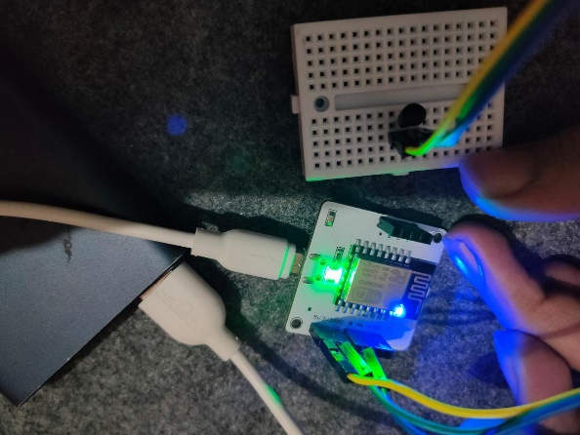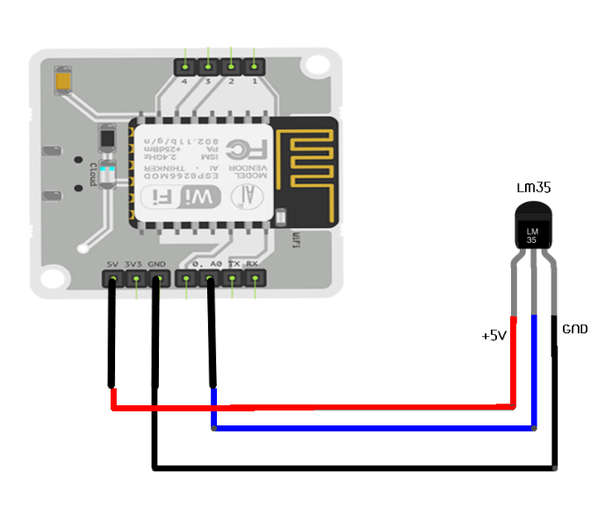

1. 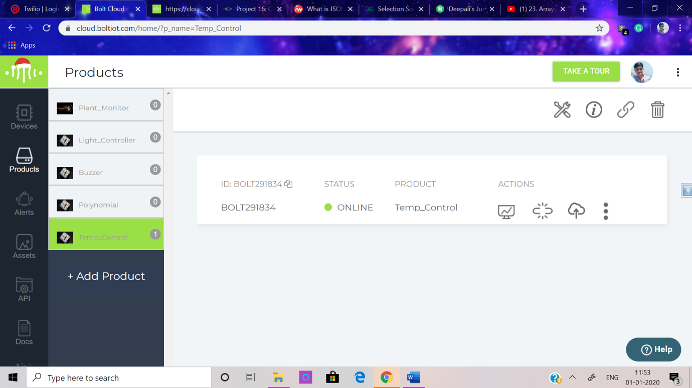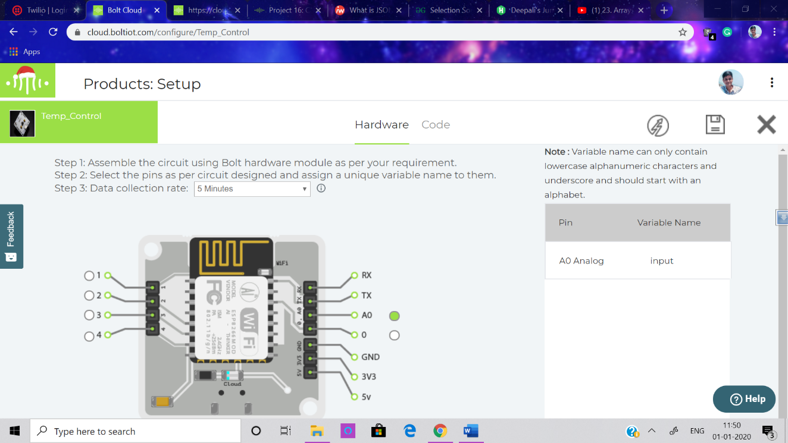**Creating Product on Bolt Cloud and linking it: -**
2. **Polynomial Regression Curve** **Code: -**
3. **Bolt with circuit in Refrigerator | Readings: -**

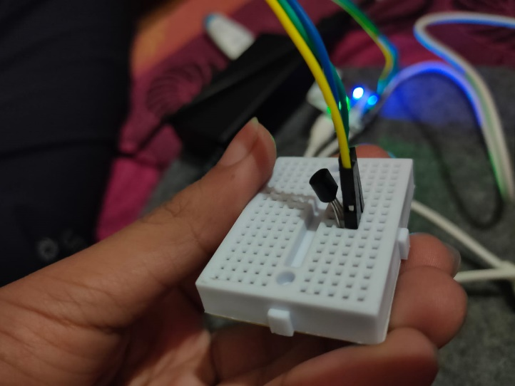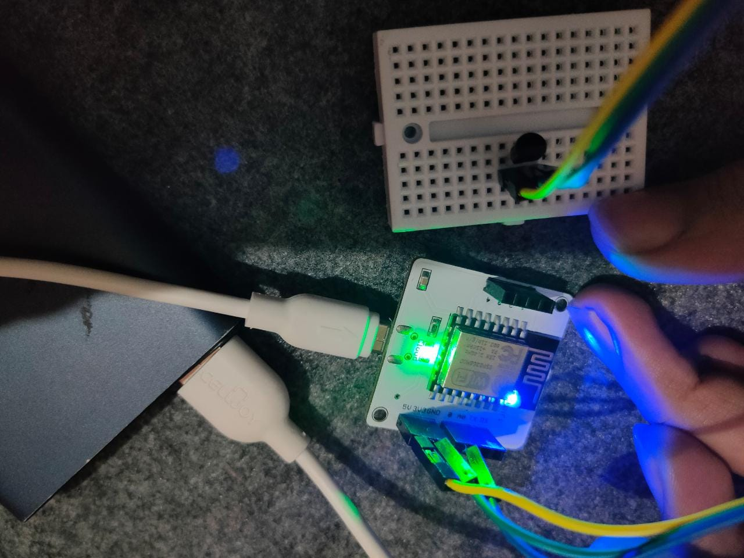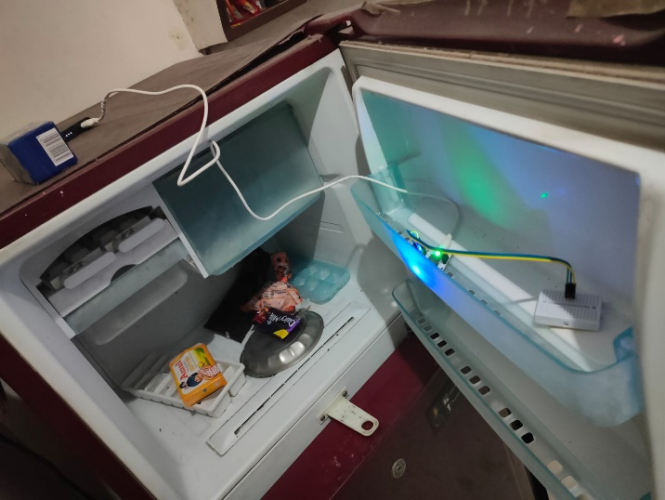

1. **Setting Boundaries: -**

As according to the readings, Temperature varies from 7 degree to 0 degree Celsius. Hence, I have set boundaries from 0 to 10.

1. **Python Code: -**

I have used gedit File.py command instead of nano File.py as I found it more comfortable, I also had kali Linux installed so, I performed everything there, hence the layout might look a bit different though ORIGINAL.

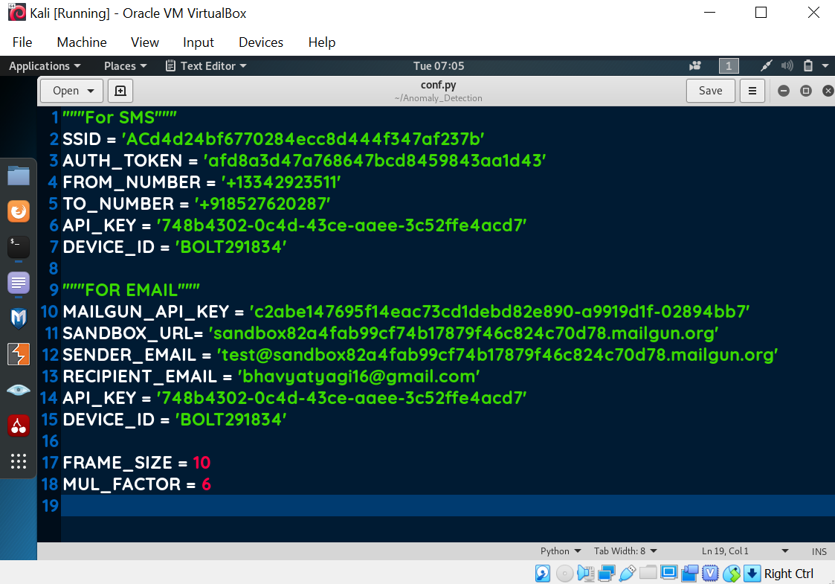**Conf.**

**Python Code for Readings: - Same as Modified Code Without Z-score Analysis.**

1. 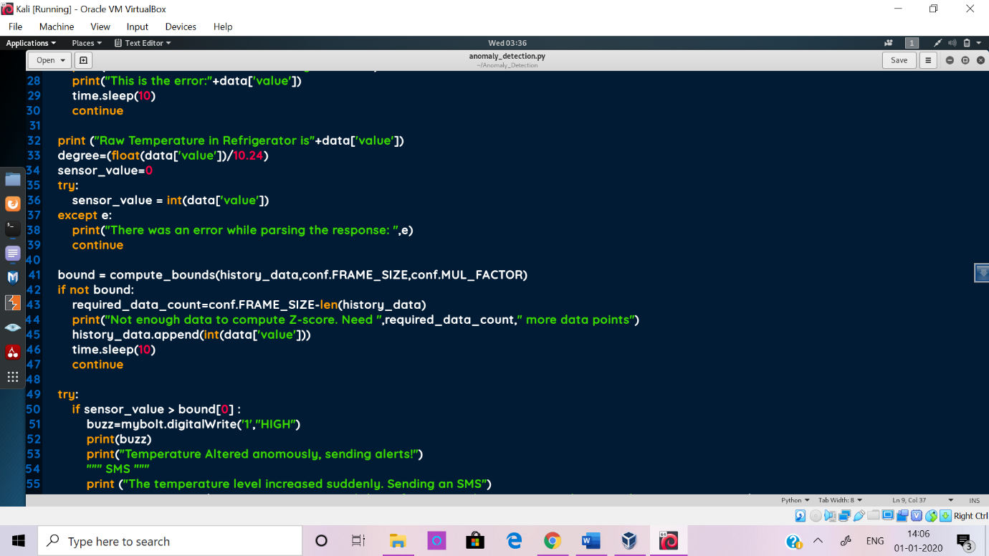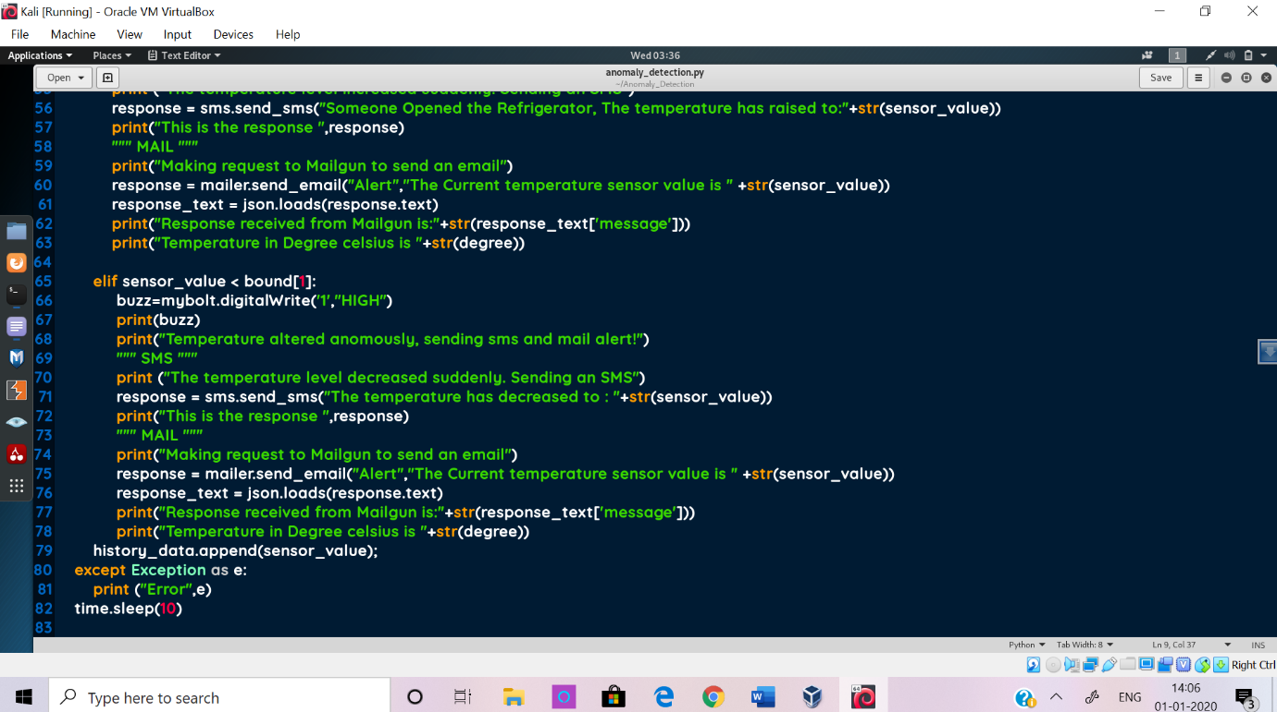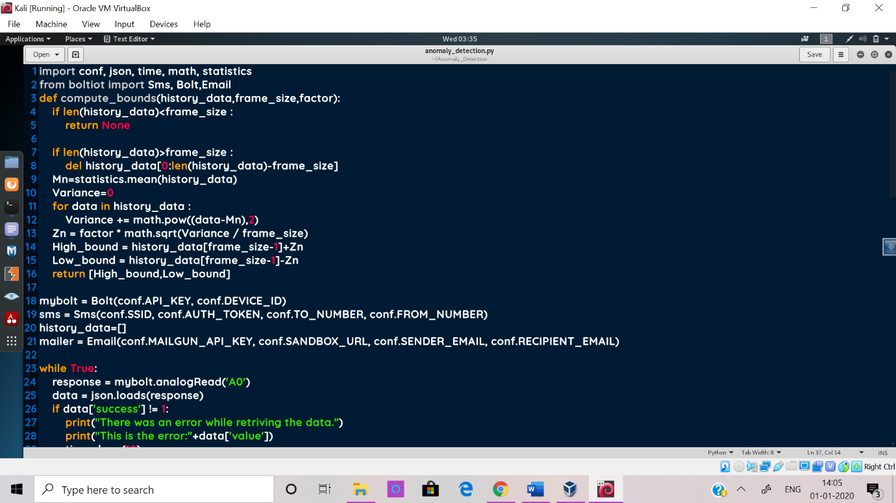**Modified Python Code | Z-score Analysis: -**
2. **Anomaly Detection: -**

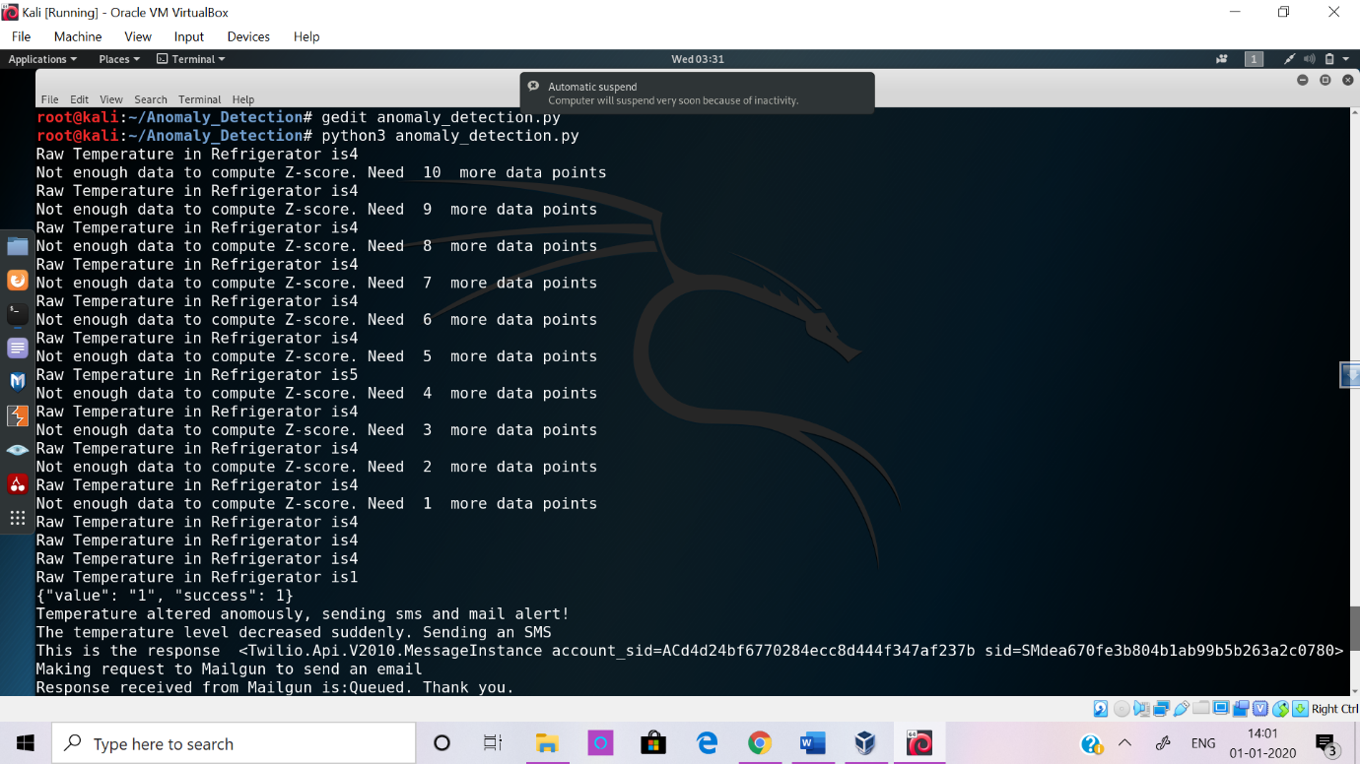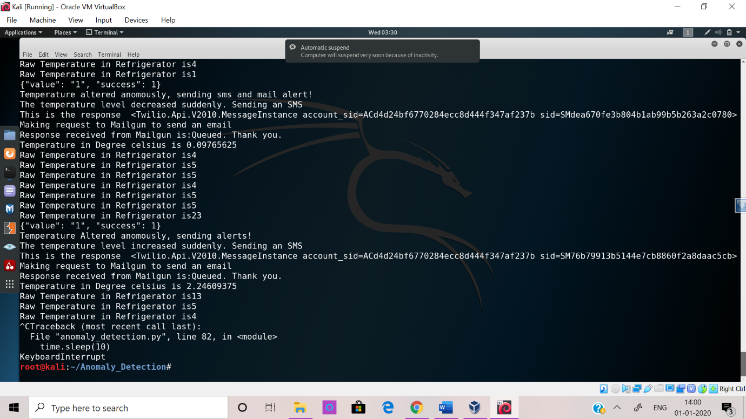**In Virtual Box: -**

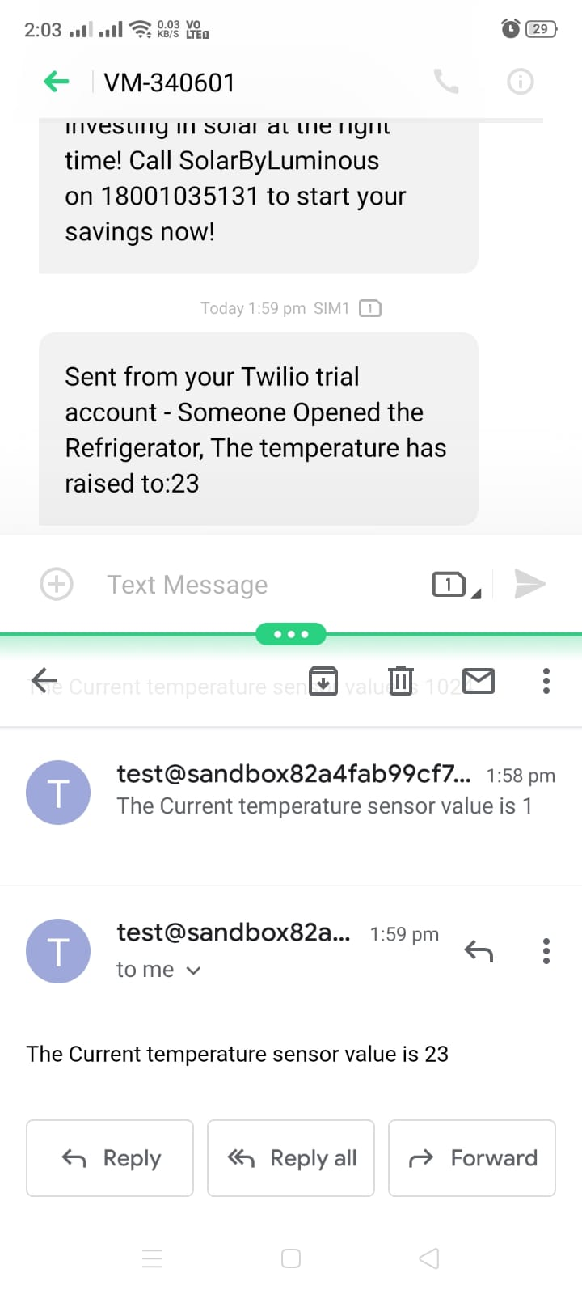**On Mobile Phone: -**

1. 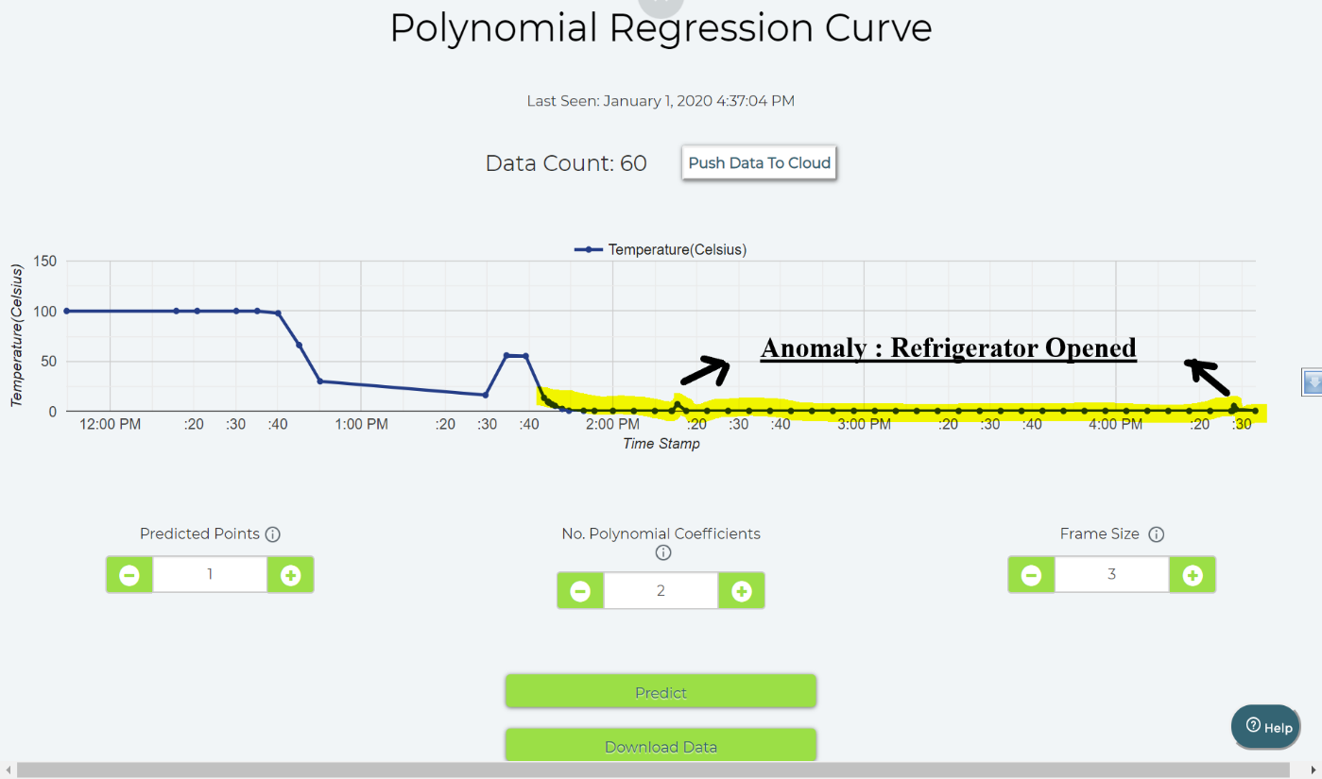**Graphical Representation: -**

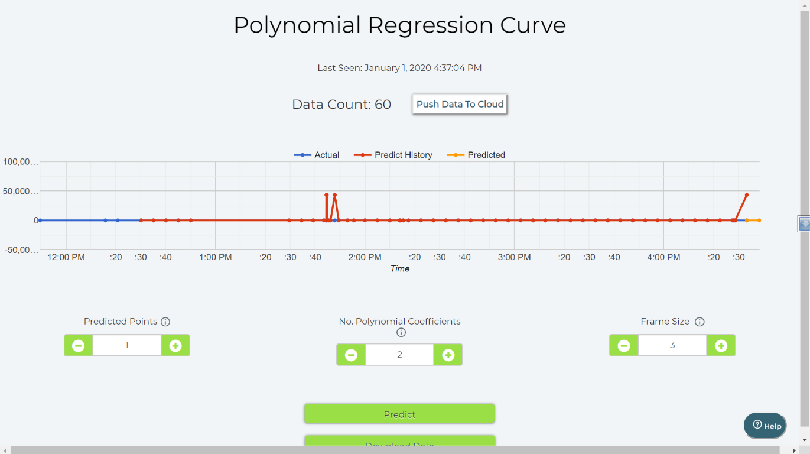

**Submitted by – Bhavya Tyagi**

**(**[**bhavyatyagi16@gmail.com**](mailto:bhavyatyagi16@gmail.com)**)**